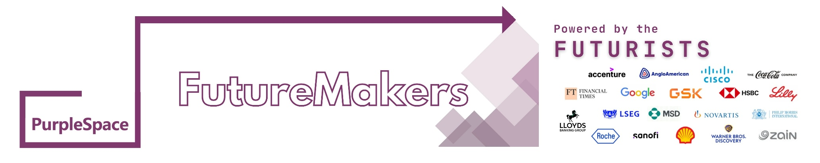

# FUTUREMAKER APPLICATION FORM

Disability ERGs and Networks are driving the next phase of workplace culture around the world, shifting mindsets and shaping more inclusive environments. At the heart of this movement is the PurpleSpace community, home to some of the most imaginative change-makers in business today.

The FutureMaker programme is designed to identify and develop the next generation of this leadership talent, equipping emerging disability ERG/Network leaders with the skills and confidence to drive lasting change. Applicants should be an aspiring disability ERG/Network Leader, or a newly appointed disability ERG/Network leader (e.g. in the last 6 months), or be a disability ERG/Network leader where the ERG/Network has launched within the last 12 months.

There are 50 places available sponsored by our Futurist members. Disabled and non-disabled applicants are welcomed. Futurist members receive two guaranteed, complimentary places on the FutureMaker programme, enabling them to nominate participants directly through completing the form below. Core Members can access one complimentary place through a competitive application process which begins after they complete the form below.

PurpleSpace is committed to ensuring that all candidates fully understand the time and effort required to engage in the programme. As part of the selection process, all applicants must complete this application form and participate in an informal interview. This ensures that candidates are well-prepared to fully engage in the programme, equipped with a strong leadership mindset, dedication, and a clear understanding of their responsibilities.

Please email the form to: futuremakers[@purplespace.org](mailto:recruitment@purplespace.org) by 1pm EST / 5pm CET on Tuesday 26 August 2025.

If you prefer to use any other format of application that works better for you, such as a video/voice recording, please send to futuremakers[@purplespace.org](mailto:recruitment@purplespace.org) by 1pm EST / 5pm CET on Tuesday 26 August 2025.

**SECTION ONE**

|  |  |
| --- | --- |
| Name |  |
| Employer |  |
| Country |  |
| Job Title |  |
| Email address |  |
| Relationship/role in existing ERG/Network |  |
| Name and email address of Inclusion Lead/ERG Lead holding the PurpleSpace membership subscription and approving this application |  |

**SECTION TWO**

We are looking for applicants who have the greatest opportunity and/or potential to support the process of positive cultural change when it comes to running disability ERG/Networks. The five core competencies we are looking for are:

* Bringing about/capacity to effect cultural change
* Delivering results
* Engaging with people at all levels
* Making decisions
* Building disability confidence

Submit a short email, audio, or video (max 350 words or 2 minutes)

Your submission should cover:

* Why you want to join the FutureMaker programme
* How you’re currently involved (or hope to be involved) in a disability ERG/Network
* The impact you hope to make through this opportunity

We’re looking for authenticity, passion, and potential. Whether you prefer writing, speaking, or filming, it is your perspective and story that count.

Please ensure to confirm that your application is endorsed by the current DEI Lead or ERG Lead holding the Purplespace membership subscription, and make sure to copy this person in your submission to futuremakers[@purplespace.org](mailto:recruitment@purplespace.org).